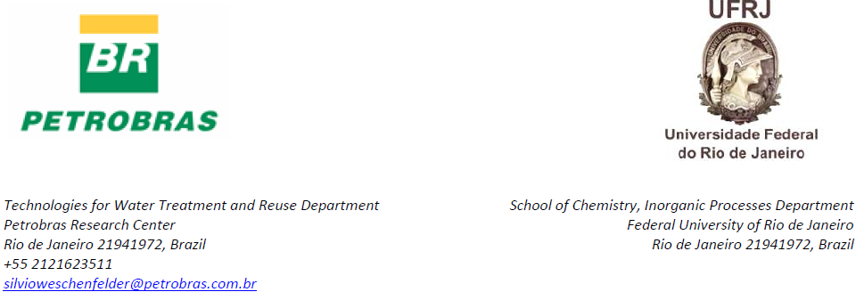

March 04th, 2015

AVALIAÇÃO EM ESCALA PILOTO DE MEMBRANAS PARA O TRATAMENTO DE ÁGUA PROVENIENTE DO PROCESSO DE EXTRAÇÃO DE PETRÓLEO

Silvio Edegar Weschenfelder*^{a, b}
Cristiano Piacsek Borges^{c}
Juacyara Carboneli Campos^{b}

ª Leopoldo Américo Miguez Research Center, Petrobras, Brazil
^{b} Inorganic Processes Department,School of Chemistry, Federal University of Rio de Janeiro, Brazil
^{c} Chemical Engineer Program, COPPE, Federal University of Rio de Janeiro, Brazil
*corresponding author

silvioweschenfelder@petrobras.com.br
cristiano@peq.coppe.ufrj.br
juacyara@eq.ufrj.br

Dear Editor:

As the corresponding author, I have read all submission instruction and I am responsible for the information inserted in the submission procedure. I assure that the contribution is original and unpublished, and it is not being evaluated for publication by other journal and that it will not be withdrawn from the editorial processes until final decision from the journal’s administration.
Please find attached for your kind review our manuscript entitles “Evaluation of membranes for oilfield produced water treatment”, Avaliação de Membranas para o Tratamento de Água Proveniente do Processo de Extração de Petróleo” in portugues.
This study is about the use of ultrafiltration membranes for treating oilfield produced water. To our knowledge this is the first report related to experiments with a real effluent obtained from an oilfield. The results provide new information for the oil exploration and production industry on the key parameter to design a full scale system for treating oilfield produced water.
I warrant that this manuscript has been read by all co-authors and I have submitted this manuscript on behalf of all the authors with their full consent.

The authors do not have any financial interest with this publication that could compromise the integrity of this publication.
The following list brings the authors, and corresponding filiations, that contributed to produce this paper:

Look forward to your favorable consideration.
Most sincerely,
Silvio Edegar Weschenfelder
Reviewers suggested:
José Jailton Marques, D.Sc.
Email: jjailton@ufs.br
Currículo Lattes: http://lattes.cnpq.br/0327054232898199
Vívian Tavares de Andrade, D.Sc.
Email: vivian.tavares.GORCEIX@petrobras.com.br
Currículo Lattes: http://lattes.cnpq.br/0502378575117823
Andréa Azevedo Veiga, D.Sc.
Email: andreaveiga@petrobras.com.br
Currículo Lattes: http://lattes.cnpq.br/6049613154663772
Fabiana Valéria da Fonseca, D.Sc.
Email: fabiana@eq.ufrj.br
Currículo Lattes: http://lattes.cnpq.br/8778107230566167

All of them are good evaluators of this work for having experience in the treatment of industrial effluents.

