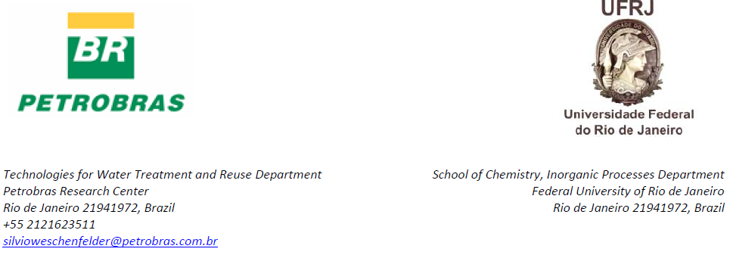

December 16th, 2014

Dear Editor:

Please find attached for your kind review our manuscript entitles “Application of membranes for oilfield produced water treatment”.

The study is about the use of ultrafiltration membranes for treating oilfield produced water. To our knowledge this is the first report related to experiments with a real effluent obtained from an oilfield. The results provide new information for the oil exploration and production industry on the key parameter to design a full scale system for treating oilfield produced water.

I warrant that this manuscript has been read by all co-authors and I have submitted this manuscript on behalf of all the authors with their full consent.

As the corresponding author, I have read all submission instruction and I am responsible for the information inserted in the submission procedure. I assure that the contribution is original and unpublished, and it is not being evaluated for publication by other journal and that it will not be withdrawn from the editorial processes until final decision from the journal’s administration.

The following list brings the authors, and corresponding filiations, that contributed to produce this paper:

Silvio Edegar Weschenfelder*^{a, b} silvioweschenfelder@petrobras.com.br
Ana Carina Cruz de Mello ^{a, b} carinacmello@yahoo.com.br
Cristiano Piacsek Borges^{c} cristiano@peq.coppe.ufrj.br
Juacyara Carboneli Campos^{b} juacyara@eq.ufrj.br

ª Petrobras Research Center, Brazil
^{b} School of Chemistry, Inorganic Processes Department, Federal University of Rio de Janeiro, Brazil
^{c} COPPE/Chemical Engineer Program, Federal University of Rio de Janeiro, Brazil

Look forward to your favorable consideration.

Most sincerely,
Silvio Edegar Weschenfelder
Reviewers suggested:
José Jailton Marques, D.Sc.
Email: jjailton@ufs.br
Currículo Lattes: http://lattes.cnpq.br/0327054232898199
Vívian Tavares de Andrade, D.Sc.
Email: vivian.tavares.GORCEIX@petrobras.com.br
Currículo Lattes: http://lattes.cnpq.br/0502378575117823
Andréa Azevedo Veiga, D.Sc.
Email: andreaveiga@petrobras.com.br
Currículo Lattes: http://lattes.cnpq.br/6049613154663772
Fabiana Valéria da Fonseca, D.Sc.
Email: fabiana@eq.ufrj.br
Currículo Lattes: http://lattes.cnpq.br/8778107230566167

All of them are good evaluators of this work for having experience in the treatment of industrial effluents.

